**Trignonometric Functions & Animating Circular Paths**

**Sine & Cosine Definitions**

The sine and cosine functions are defined on what is called the **unit circle**, which is a circle with a **radius of 1** and centered at the **origin**, (0,0).

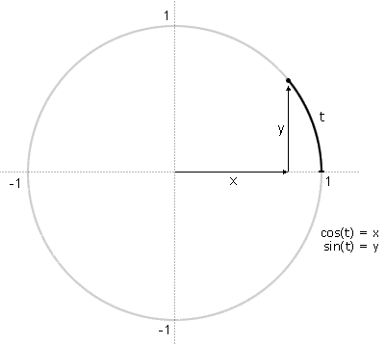

**t is the length of an arc** that starts at the right side of the circle and proceeds in a counter-clockwise (or anti-clockwise) direction. **Cosine(t) and sine(t) give the x and y coordinates**, respectively, of the end point of the arc. Note that as t varies, we can follow the full path of the circle.

There are a few important things to notice:

* **t keeps going around and around the circle**, and so the sine and cosine values **keep repeating.**
* cosine and sine values are **always between 1 and -1**
* for any **t**, the point **(cos t, sin t)** is a **distance of 1** from the centre
* the **circumference** of the unit circle is **2*pi**

**TRIGONOMETRIC FUNCTIONS AND CURVED/CIRCULAR ANIMATION:**

Trigonometric functions are useful for defining curved and circular animation paths - especially when attempting to animate these paths.

Imagine drawing a circle with a pencil, and placing mile (or km) markers around it as you go. You start with 0, go to 1, 2, etc. Imagine that a circle takes just over 6 mile markers to complete. This would be measuring the circumference in radians. If you were to measure it in degrees, it would take exactly 360° to get around the full circumference of the circle.

**The sin and cos functions:**

They define the circumference of a circle (see above).

**Remember:**

A circle is defined by two facts: the position of the centre of a circle, and the radius. For example, the circle below is centred at point (320, 240), and has a radius of 100.

So how do you locate a point on the edge of the circle? JavaScript/canvas doesn’t understand mile markers. Programming environments only ‘know’ points as horizontal and vertical locations.

This is where sine and cosine become useful. They take a position along the circumference of a circle and convert it to a screen location. To get the horizontal screen location, you would use cosine.

Therefore the horizontal position of mile marker t is given by the radius of the circle, times(*) the cosine of t, plus the horizontal centre of the circle:

**X = 100.0*cos(t) + 320**

The vertical position is given by:

**Y = 100.0*sin(t) + 240**

Say if t was equal to 4, the result is then the point (255, 164)

The usefulness of plotting points along a circle is that you can animate objects along circles. All you need to do is to calculate the x and y coordinates as you move along the circumference. So you start at mile marker 0, and move along the edge.

In general we can say that – given the ***centre*** and ***radius*** of a circle - we can animate the path of this circle using the following parametric equation:

x = radius*cos(t) + xcoordOfCentrePoint

y = radius*sin(t) + ycoordOfCentrePoint

**A Note on Radians:**

Radians are **also defined on the unit circle**. In the diagram below, the angle ***r*** (by definition) has a size of **t** radians.

There are 2*pi radians in a full rotation. We know already that there are 360 degrees in a full rotation. Therefore **2*pi radians must be = 360 degrees**.

Therefore 1 degree = pi/180 radians.

i.e.

To convert from **degrees to radians**, multiply by **(2 * pi) / 360** (or pi/180)

To convert from **radians to degrees**, multiply by **360 / (2 * pi)** (or 180/pi)

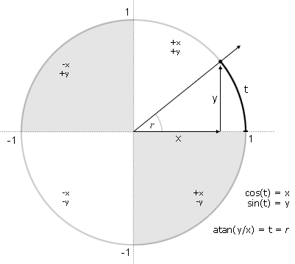

=71

=-71

(320,240))

45°

(391, 169)

Equation of Circle: (Cartesian coordinates):  
For a circle with centre **(j, k)** and radius **(r):**  
    **(x-j)2 + (y-k)2 = r2**

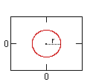

Equation of a Circle: (parametric coordinates):  
For a circle with origin (j, k) and radius r:  
**x(t) = r cos(t) + j       y(t) = r sin(t) + k**

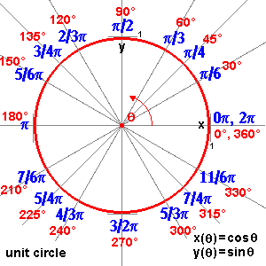

**A Note on Pi:**

**π** (sometimes written **pi**) is a mathematical constant whose value is the ratio of any circle's circumference to its diameter. It is approximately equal to 3.141593 in the usual decimal notation. Many formulae from mathematics, science, and engineering involve π, which is one of the most important mathematical and physical constants.